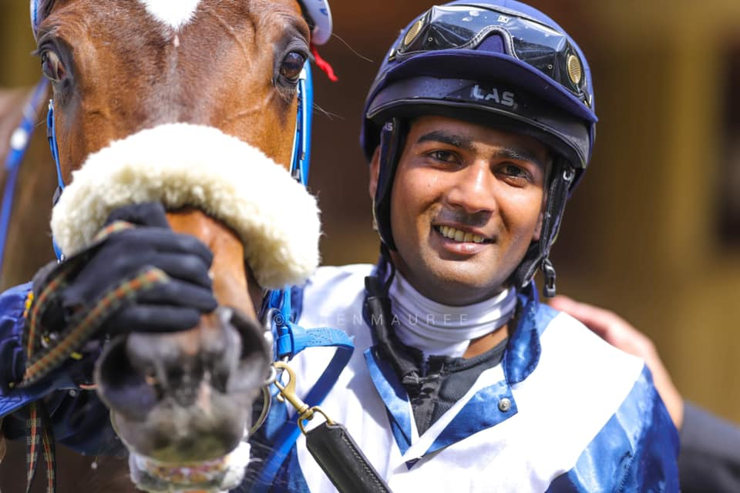

Contact File
Name: Kersley Ramsamy
Address: Morcellement Dhunputh, Belle Vue, Chemin Grenier, Mauritius
Nationality: Mauritian
Telephone Number: +23058133246
Email Address: kersley07@gmail.com
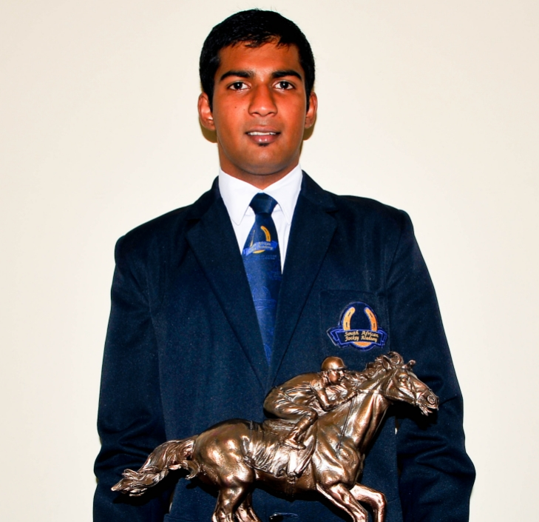

Fact File
Started Apprenticeship : 2013
Ended Apprenticeship : 2017
Apprenticeship made : SAJA (South African Jockey Academy)

Riding Master: Tex Davie
Riding Weight: 55.5kg
Winners ridden up to now: 70
Featured Race Won: Lightning Cup (Gr2) with Rule The Night – Mauritius, The Princess Margaret Cup (Gr1) with Rule The Night - Mauritius
Rode in: South Africa, Mauritius, Italy, France, Oman, Germany, Abu Dhabi
Honours: Won the Eastern Cape Champion Apprentice in 2016, won a race in france in the Sheikha Fatima Bint Mubarak Apprentice World Championship with Thabit

PS: I’ve never been charged under the ‘permissible measures’ in the said countries I’ve ridden. Which mean I got a clean record.

Media Section

With the Lightning Cup winner, Rule The Night
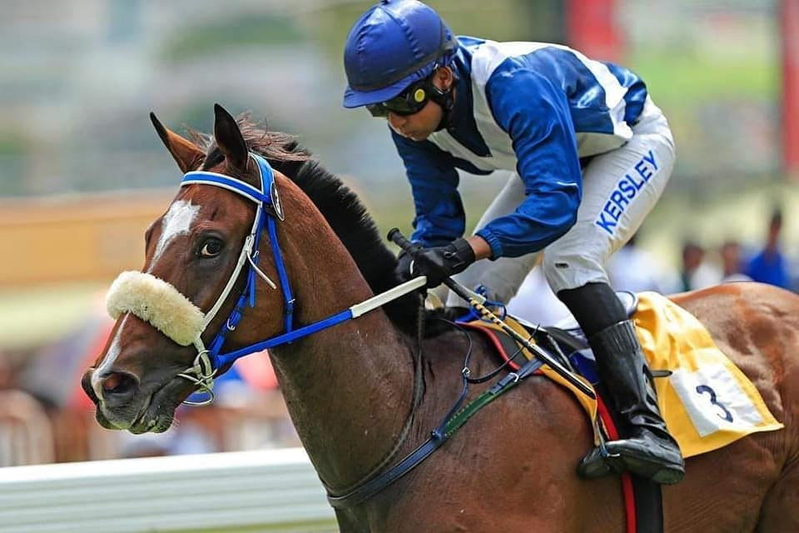
Youtube Link – Rule The Night (Lightning Cup) – Group 2
https://youtu.be/jeKhvgVBr-M
Winning the Princess Margaret Cup with Rule The Night
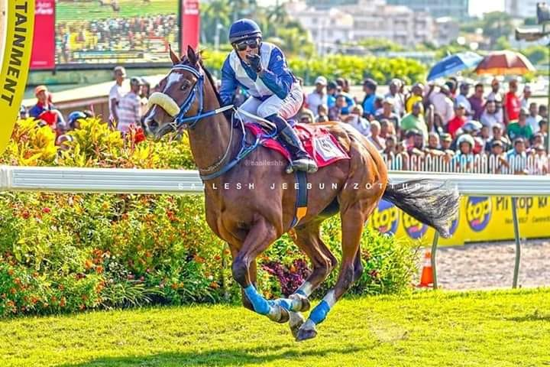
Youtube Link – Rule The Night (Margaret Cup) – Group 1
https://youtu.be/b3znYkfCxWc

In Abu Dhabi representing Mauritius
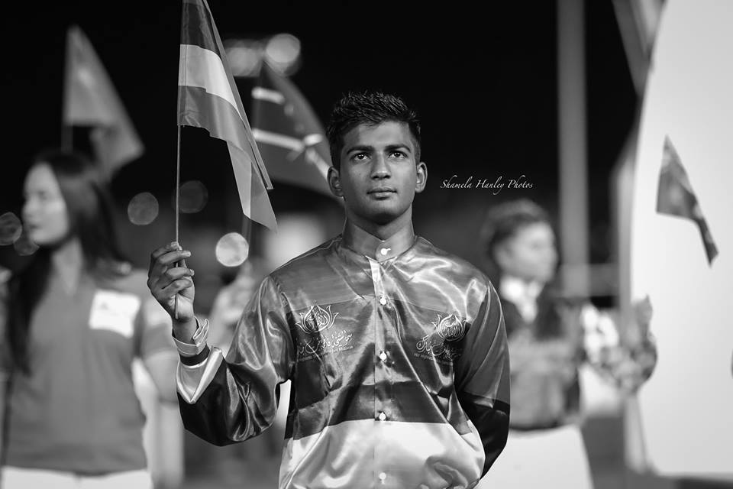

In the South African Jockey Academy (3rd top row from the left)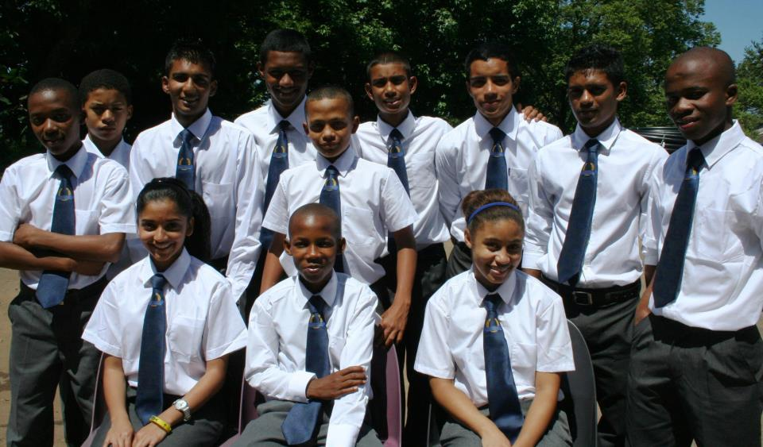

In France after winning with Thabit
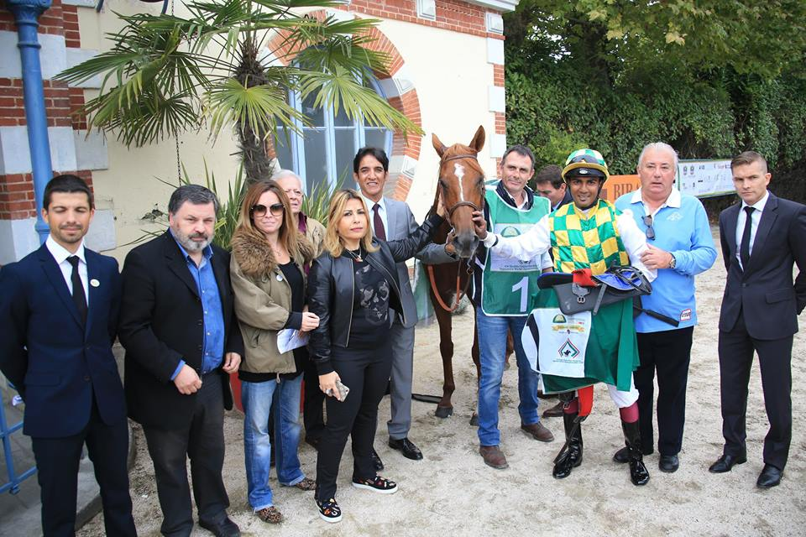
Youtube Link – Win & Interview with local press
https://youtu.be/jeKhvgVBr-M

Feel free to contact me,
Kersley

